PARAKH – Bulk User Upload User Manual
User Guide for Bulk Creation of Users Using Excel
1. Purpose
The Bulk User Upload option allows the administrator to add multiple users in PARAKH using an Excel file, instead of creating each user one by one through Create User. The page states that many users can be created at once, with up to 50 rows per upload.
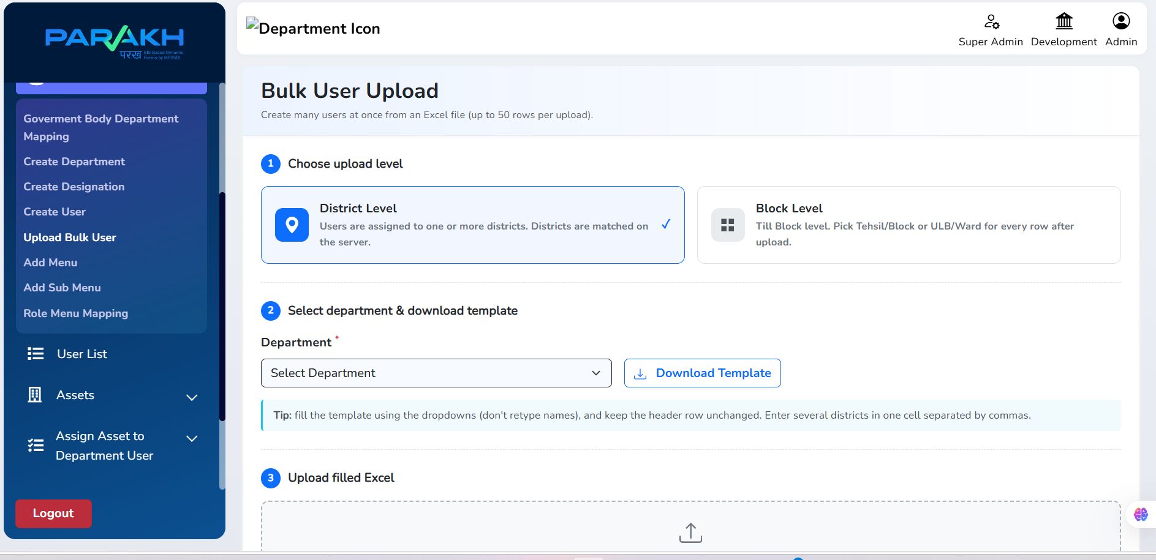
Figure 1: Bulk User Upload page in PARAKH
2. Accessing Bulk User Upload
- Log in to PARAKH.
- From the left menu, go to Admin → Upload Bulk User.
- The Bulk User Upload page opens. It has three parts: Choose upload level, Select department & download template, and Upload filled Excel.
3. Step 1 – Choose Upload Level
Two options are shown on the page. Select the one that matches how the users should be assigned.
District Level
- Users are assigned to one or more districts.
- The districts are matched on the server.
Block Level
- Used when users need to be assigned at Tehsil/Block or ULB/Ward level.
- The page says to pick the Tehsil/Block or ULB/Ward for every row after upload.
4. Step 2 – Select Department and Download Template
- Select the required Department from the dropdown (this field is marked as required).
- Click Download Template. An Excel template is downloaded.
- Open the template and enter the user details.

Important Notes
- Fill the template using the dropdowns wherever they are given. Do not retype the names manually.
- Keep the header row unchanged.
- For District Level, if a user needs more than one district, enter them in the same cell separated by commas.
- Only up to 50 rows can be uploaded at a time.
5. Step 3 – Upload Filled Excel
- Complete the downloaded Excel template.
- Come back to the Bulk User Upload page and go to the Upload filled Excel section.
- Upload the filled Excel file there. The system then processes the entries.
Maximum: 50 rows per upload.
6. Verify Uploaded Users
After the Excel upload is processed, go to User List in the left menu. The newly uploaded users should be displayed there, so the administrator can check that the entries have been added.
Workflow Summary
Login | → | Admin → Upload Bulk User | → | Select Upload Level
 |  |  |  | ↓
Fill Excel File | ← | Download Template | ← | Select Department
↓
Upload Excel | → | Users Added | → | Verify in User List

